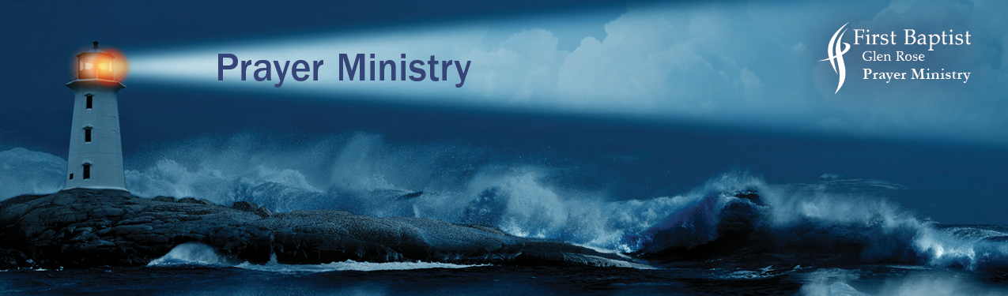
Praying for Your Unsaved Family and Friends

As we faithfully pray for our family and friends, we must also be watchman where it counts the most - the unbelievers. These are key principles that will help you intercede fruitfully.
Pray with precise prayers with authority and confidence in Jesus Christ.

Prayer precedes conversion
Jesus prayed for the salvation of those yet to believe through the disciples’ teaching.
“I do not ask for these only, but also for those who will believe in me through their word.”
(John 17:20)
Paul prayed, “Brothers, my heart’s desire and prayer to God for them is that they may be saved.”
(Romans 10:1)

Pray from the viewpoint of how God sees the unsaved
God has a heart for the unsaved person, “not wishing that any should perish, but that all should reach repentance.” 2 Peter 3:9
He sent His Son, “to seek and save the lost.” (Luke 19:10)

Present your family, friends, co-workers by name before the throne of God
Paul urged Timothy, “ First of all, then, I urge that supplications, prayers, intercessions, and thanksgivings be made for all people, for kings and all who are in high positions, that we may lead a peaceful and quiet life, godly and dignified in every way. This is good, and it is pleasing in the sight of God our Savior, who desires all people to be saved and to come to the knowledge of the truth. For there is one God, and there is one mediator between God and men, the man Christ Jesus, who gave himself as a ransom for all, which is the testimony given at the proper time.” (1 Timothy 2:1-6)

Pray for a stirring of the Spirit
“No one can come to me unless the Father who sent me draws him. And I will raise him up on the last day.” (John 6:44)

Pray for conviction
“And when he comes, he will convict the world concerning sin and righteousness and judgment…”
(John 16:8)

Pray for revelation
“For what we proclaim is not ourselves, but Jesus Christ as Lord with ourselves as your servants for Jesus’ sake. For God, who said, “Let light shine out of darkness,” has shone in our hearts to give the light of the knowledge of the glory of God in the face of Jesus Christ.” (2 Corinthians 4:5-6)

Pray for confession with repentance leading to salvation
“If you confess with your mouth that Jesus is Lord and believe in your heart that God raised him from the dead, you will be saved.”
(Romans 10:9)

Why is it so hard for some people to come to Jesus?
Until we accept Jesus Christ as Savior and Lord we are set up against the plans of God. This puts us in a position against the Lord where the enemy of our soul has a great freedom of our souls to manipulate us.
In Ephesians 2:2, we read “…in which you once walked, following the course of this world, following the prince of the power of the air, the spirit that is now at work in the sons of disobedience.”

Pray diligently for the lost to seek the Lord
“that they should seek the Lord and perhaps feel their way toward him and find him.” (Acts17:27b)
“Seek the Lord while he may be found; call upon him while he is near;” (Isaiah 55:6)

In the Scripture it is very clear why some people are resistant to the Gospel.

Pray for blinded eyes to be open to the truth of the gospel
“The god of this world has blinded the minds of the unbelievers, to keep them from seeing the light of the gospel of the glory of Christ who is in the image of God.”
(2 Corinthians 4:4)

Pray against the word of salvation to be snatched away but to take root and grow in hearts
“As he sowed, some seeds fell along the path, and the birds came and devoured them… When anyone hears the word of the kingdom and does not understand it, the evil one comes and snatches away what has been sown in his heart.” ( Matthew 13:4,19)

Because these stumbling blocks set up by the enemy to slow down our efforts to reach those who need to know Christ, we need to be in PRAYER.
Jesus is interceding today. Stand strong in prayer with the Lord.

*Pray purposefully and specifically for the unbeliever (John 17:20-21)
*Pray with boldness and in faith before the Lord (Ephesians 6:18)
*Cry out to God with compassionate concern (John 17:20-21)
*Fast and pray consistently (Acts 14:23)
*Never give up! (Luke 18:1)

Praying for those you know well
Pray against the hold of negative or sinful habits. Pray for repentance and become a new creation in Christ.
(2 Corinthians 5:7)
*Pray against people who affect the unbeliever negatively. Pray they seek righteousness (2 Corinthians 6:14)
*If there are activities that bring a negative influence, pray they will be replaced with positive activities (Galatians 5:1)
*Pray any negative experiences from the person’s past will be healed in such a way that Christ’s power is evident. (Romans 6:1-4)
*Pray that the Holy Spirit will bring genuine believers into his or her life to speak about Christ, realizing it might be you as the believer. (Colossians 4:3)

Praying for those you do not know well
“For the weapon of our warfare are not of flesh but have diving power to destroy strongholds. We destroy arguments and every lofty opinion raised against the knowledge of God, and take every thought captive to obey Christ” (2 Corinthians 10:4-5)

*Pray that God would open their eyes to the truth of the gospel (Acts 26:18)
*That God draws then to himself (John 6:44)
*That the Holy Spirit work in their lives (John 16:13)
* That they would believe the Scriptures (1 Corinthians 2:14)
*That they confess Christ as Savior and Lord (Romans 10:9)
* That they would trust and follow Christ as a disciple always.(Colossians 2:6)

Praise God for his victory over the power of the enemy.
“You are my King, O God; ordain salvation for Jacob! Through you we push down our foes; through your name we tread down those who rise up against. For not in my bow do I trust, nor can my sword save me. But you have saved us from our foes and have put to shame those who hate us. In God we have boasted continually, and we will give thanks to your name forever.”
(Psalm 44:4-8)
“ So he saved them from the hand of the foe and redeemed them from the power of the enemy.”
(Psalm 106:10)

All Scripture references are ESV

