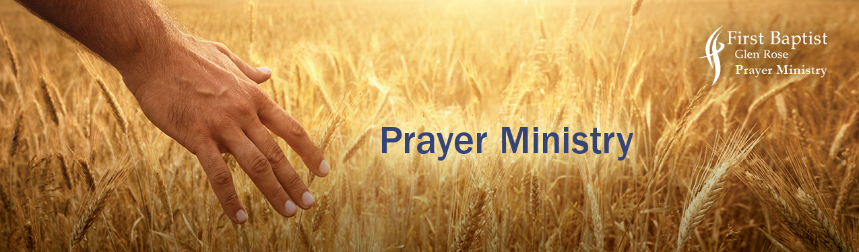

Harvest Prayer Targets

“When he saw the crowds, he had compassion for them, because they were harassed and helpless,
like sheep without a shepherd. Then he said to his disciples, ‘The harvest is plentiful, but the laborers
are few; therefore pray earnestly to the Lord of the harvest to send out laborers into his harvest.’ ”
Matthew 9:36-37

Lord, give us eyes to see people the way you see them
and caring hearts to share the gospel with them. Amen.

FRIENDS * NEIGHBORS * WORK SCHOOL * SPORTS * CHURCH
A close friend Administrators
Friends not seen recently Teachers
Acquaintances not known well Parents of your children’s friends
A complete stranger
Coaches
Neighbor you know well Parents of your children’s team
Neighbor you don’t know well Your coach
Neighbor you have not met Your team members

Boss Church visitors
Co-workers Church service personnel
Employees Church technicians
Clients
Customers Clubs, Service Organizations,
Suppliers and Affiliation members

TECHNICIANS * GOVERNMENT SERVICE * SHOPPING
Repair technicians: FedEx Staples workers
Electrical, Plumbing Ranch Care—plow, plant, dozier, cattle
AC, Heat, Water Well Carpet Cleaners, Window Washers
Auto Shop Housekeepers
Generator, Propane Dry Cleaners
Lawn Care workers
State Representatives, Senators Barber, Beautician, Nail Techs
City Council members Doctors and Nurses
County Commissioners Grocery and store personnel
Administrators, Postal Firemen and EMS clinicians
Police, Sheriff, Deputies Restaurant workers, managers, chefs

