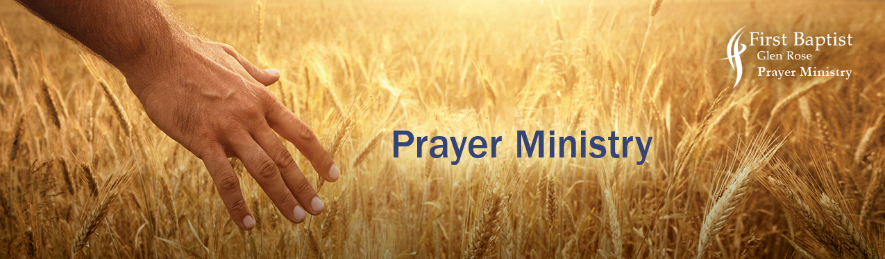

THE HARVEST

“When he saw the crowds, he had compassion on them, because they were harassed and helpless, like sheep without a shepherd.
Then he said to his disciples, ‘The harvest is plentiful, but the laborers are few; therefore pray earnestly to the Lord of the Harvest to send out laborers into his harvest.” Matthew 9:36-37

PRAY CONFIDENTLY AND ASSURED
+God says their salvation is possible Matt. 10:27
+God is desiring that they be saved 2 Peter 3:9
+God asks for people to go to the Harvest field Matt.9:37

Pray to see the people in your life with God’s eyes Matt 9:36
Pray for a renewed passion energized for the lost Romans 10:1

Pray for open doors to revive or enhance a relationship with them Colossians 4:3-4
Pray for courage and boldness to speak Jesus and give an invitation to come to church Ephesians 6:19 Psalm 66:5

Through prayer come before the throne of God and present them by
calling out loud their names to God. Hebrews 4:16
Name___________________ and ___________________.

Pray the Lord will draw them to Himself John 6:44
Pray their hearts are softened and open to receive the Word of God leading to a revelation of Jesus 2 Corinthians 6:11-13
Pray their eyes are opened 2 Corinthians 4:4
Pray for conviction of sin and righteousness in Christ John 16:8
Pray they will accept the invitation for salvation Ephesians 2:8
Pray they will desire to be baptized and be a Christ follower Matt. 3:15-16
Pray for the joy of salvation in Jesus Habakkuk 3:18

OUR ENEMY, THE DEVIL, SEEKS TO STEAL THEM AWAY
PRAY FOR PROTECTION AND TO STOP HIM. MATT. 13:4, 19
1. Pray the seed of the Word will not be stolen, but take root and grow to maturity in Jesus
2. Pray against the busyness of schedules that diminishes their new relationship with Jesus
3. Pray against the cares of the world that would choke out the love for Jesus
4. Pray against any strongholds, arguments and pretensions that sets itself up against the knowledge of God. 2 Corinthians 10:4-5

JESUS IS VICTOR!
“So he saved them from the hand of the foe and redeemed them from the power of the enemy.”
Psalm 106:101
“But thanks be to God, who gives us the victory though our Lord Jesus Christ.”
1 Corinthians 15:57
“For everyone who has been born of God overcomes the world. And this is the victory that has overcome the world-our faith.”
1 John 5:4

